1 | Product Name | HB-D150
2 | Short brief | Barrier gates serve multiple purposes, including traffic management, security control, and revenue collection. They are designed to prevent unauthorized access to restricted areas, control the flow of vehicles, and ensure only authorized vehicles are allowed entry.
3 | 3D Drawing | 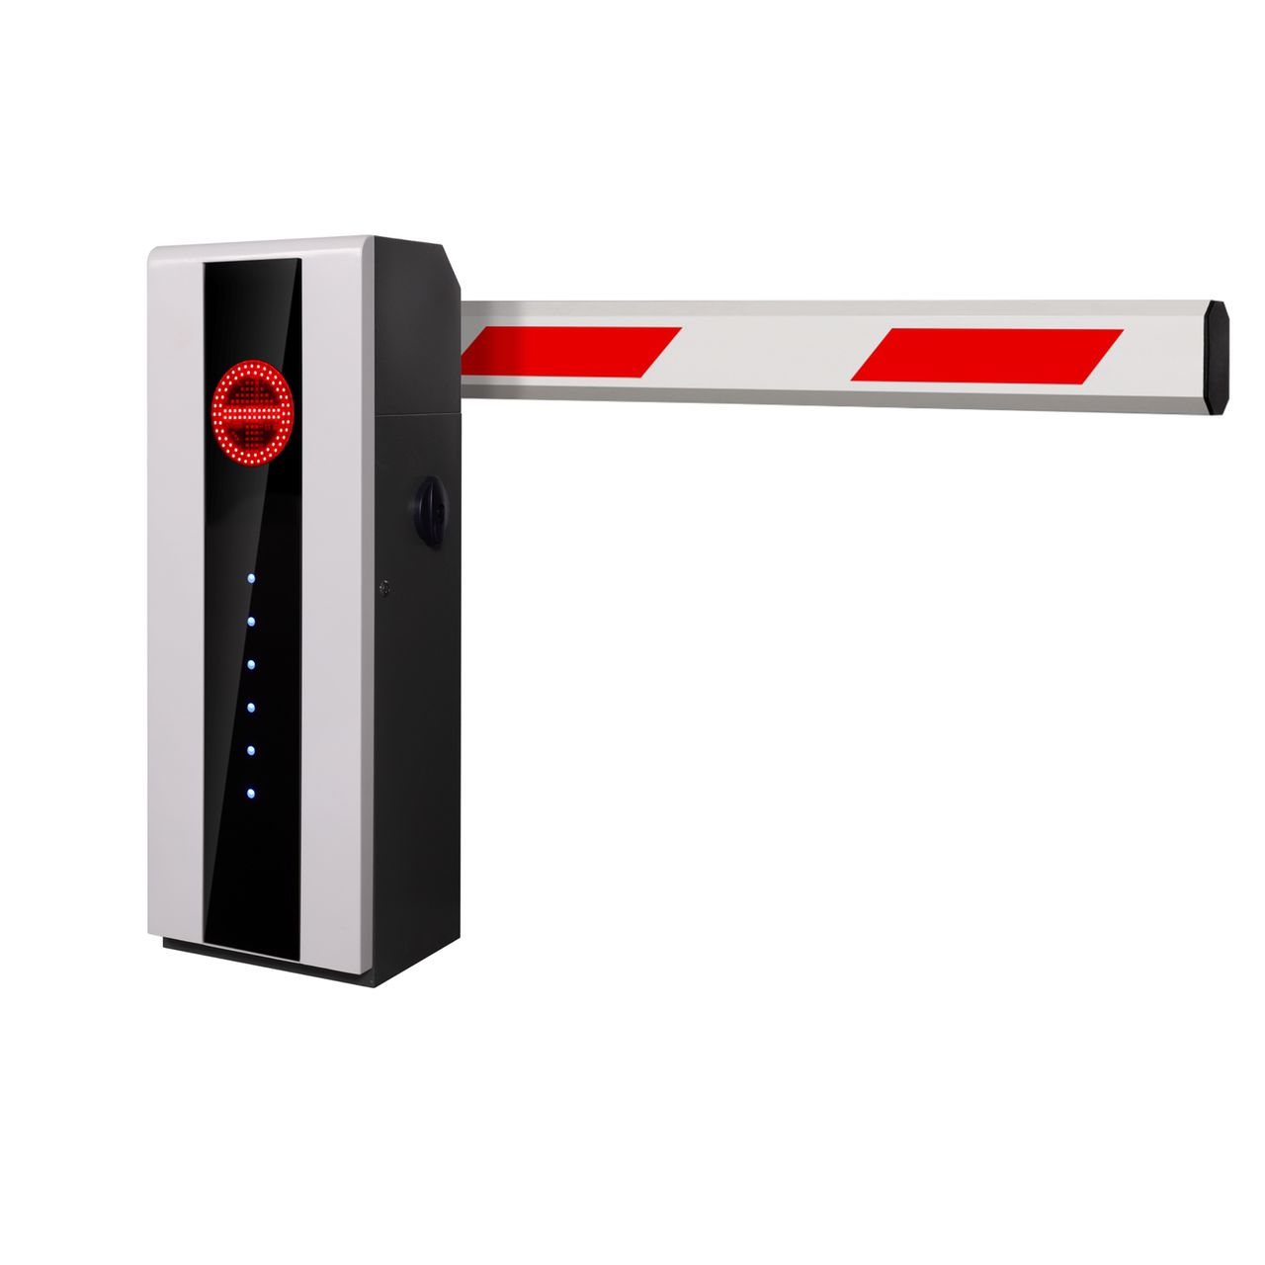
4 | Technical Specification | - Boom Length: 3m  - Opening and closing time: 0.9 sec  - Power 150 W
5 | Features | - Parts are molded  - Three phase Motor  - Worm transmission  - Less noise  - Steady drive  - High powered rely to ensure power stability  - Pressure sensor to avoid crash  - Loop detector to ensure car passes safely  - First function opening
6 | Application | - Parking Facilities  - Toll Booths  - Airports and seaports  - Educational Institutes  - Health care Facilities  - Industrial Facilities  - Government Buildings  - Hotels and Resorts  - Gated Communities  - Event Venue  - Construction sites
7 | Installation | When it comes to installation, our team of certified professionals is well-versed in the intricacies of our barrier systems. We understand that a flawless installation is crucial for both operation and aesthetics. Our installation specialists adhere to a methodically designed procedure to ensures that your barrier is smoothly integrated into your environment, meeting both safety and design requirements. Our customer service team is always available to address any queries or concerns you may have. Whether you need additional guidance post-installation or have questions about maintenance, our team is here to provide timely and expert assistance.
8 | Variants | - HI-BG 66A90  - HI-ABG 33A160

