1 | Product Name | HB145 Rapid
2 | Short brief | Barriers play a pivotal role in regulating access and ensuring security in various environments. These physical structures act as tangible obstacles that control the entry of vehicles into specific areas. The HB145 Rapid, a solution designed for swift yet guarded entry. Featuring a balance boom and rapid operational time, it stands as an optimal choice for streamlined access control.
3 | 3D Drawing | 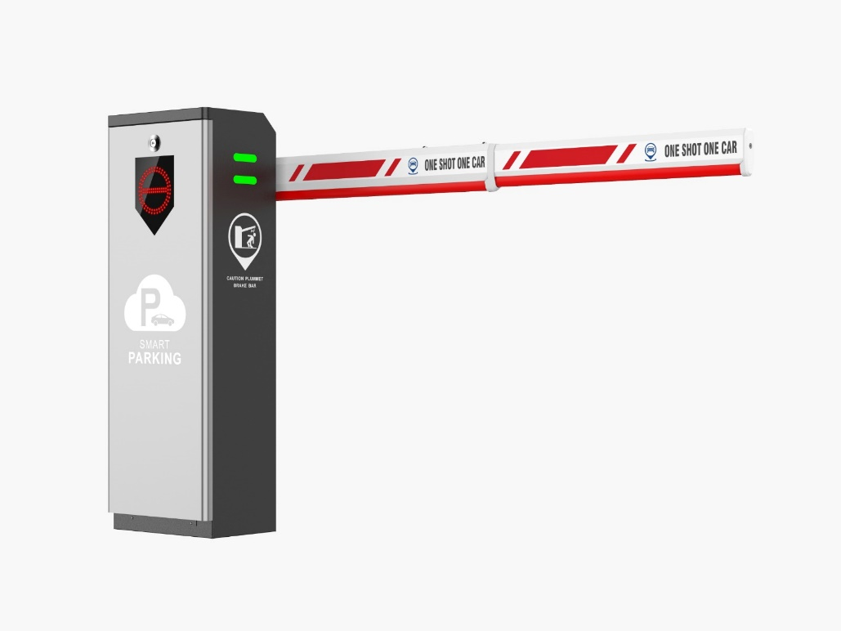
4 | Technical Specification | - Supply: 220 – 240 volts  - Power: 140 Watts  - Boom length: 4  - Opening Time: 3sec
5 | Features | - Parts are molded  - Three phase Motor  - Worm transmission  - Less noise  - Steady drive  - High powered rely to ensure power stability  - Pressure sensor to avoid crash  - Loop detector to ensure car passes safely  - First function opening
6 | Application | - Parking Facilities  - Toll Booths  - Airports and seaports  - Educational Institutes  - Health care Facilities  - Industrial Facilities  - Government Buildings  - Hotels and Resorts  - Gated Communities  - Event Venue  - Construction sites
7 | Installation | When it comes to installation, our team of certified professionals is well-versed in the intricacies of our barrier systems. We understand that a flawless installation is crucial for both operation and aesthetics. Our installation specialists adhere to a methodically designed procedure to ensures that your barrier is smoothly integrated into your environment, meeting both safety and design requirements. Our customer service team is always available to address any queries or concerns you may have. Whether you need additional guidance post-installation or have questions about maintenance, our team is here to provide timely and expert assistance.
8 | Variants | - HB150  - HB160A

